A PROJECT REPORT
ON
MAC ADDRESS FINDER
A Dissertation submitted to JNTU Hyderabad in partial fulfillment of the academic requirements for the award of the degree
Bachelor of Technology
In
Computer Science and Engineering (Data Science)

Under the esteemed guidance of
Mr. Uday Kishore / Ms. Akanksha


COMPUTER SCIENCE AND ENGINEERING (DATA SCIENCE)

CMR COLLEGE OF ENGINEERING & TECHNOLOGY
(Autonomous)
(NAAC Accredited with ‘A⁺’ Grade & NBA Accredited)
(Approved by AICTE, Permanently Affiliated to JNTU Hyderabad)
KANDLAKOYA, MEDCHAL ROAD, HYDERABAD-501401
2026-2027

CMR COLLEGE OF ENGINEERING & TECHNOLOGY
(Autonomous)
(NAAC Accredited with ‘A⁺’ Grade & NBA Accredited)
(Approved by AICTE, Permanently Affiliated to JNTU Hyderabad)
KANDLAKOYA, MEDCHAL ROAD, HYDERABAD-501401

DEPARTMENT OF COMPUTER SCIENCE AND ENGINEERING
(DATA SCIENCE)

CERTIFICATE
This is to certify that the Computer Networks Laboratory Project report entitled “MAC ADDRESS FINDER” being submitted by Arna Malwatkar (24H51A6767), Banala Jashwanth (24H51A6770), and Banala Sushanth (24H51A6771) of Bachelor of Technology in Computer Science and Engineering (Data Science) is a record of Bonafide work carried out his/her under the guidance and supervision.
The results embody in this project report have not been submitted to any other University or Institute for the award of any Degree.

Mr. Uday Kishore / Ms. Akanksha Dr. R. Venkateswara Reddy
Assistant Professors Associate Professor and HOD
Dept. of CSE(DS) Dept. of CSE(DS)

ACKNOWLEDGEMENT
With great pleasure we want to take this opportunity to express our heartfelt gratitude to all the people who helped in making this project work a grand success.
We are grateful to Mr. Uday Kishore / Ms. Akanksha, Assistant Professors, Department of Computer Science and Engineering (Data Science) for their valuable technical suggestions and guidance during the execution of this project work.
We would like to thank Dr. R. Venkateswara Reddy, Head of the Department of Computer Science and Engineering (Data Science), CMR College of Engineering and Technology, who is the major driving forces to complete my project work successfully.
We are highly indebted to Dr. K. Srinivasa Rao, Principal, CMR College of Engineering and Technology, for giving permission to carry out this project in a successful and fruitful way.
We would like to thank the Teaching & Non-teaching staff of Department of Computer Science and Engineering (Data Science) for their co-operation.
We express our sincere thanks to Shri. Ch. Gopal Reddy, Secretary, CMR Group of Institutions, for his continuous care.
Finally, we extend thanks to our parents who stood behind us at different stages of this Project. We sincerely acknowledge and thank all those who gave support directly and indirectly in completion of this project work.

TABLE OF CONTENTS
CHAPTER NO. | TITLE | PAGE NO.
 | Abstract | 1
1 | INTRODUCTION
 | 1.1 Problem Statement | 2
 | 1.2 Objective | 2
 | 1.3 Scope | 2 - 3
 | 1.4 Limitations | 3
2 | PROPOSED SYSTEM
 | 2.1 Advantages | 4
 | 2.2 Design | 4 - 5
 | 2.3 Implementation | 5 - 7
3 | RESULTS AND DISCUSSION | 8
4 | FUTURE SCOPE | 9
5 | CONCLUSION | 10

ABSTRACT
The MAC Address Finder is a Computer Networks project developed to identify and display the Media Access Control (MAC) addresses of network interfaces available on a computer. The system is implemented using Python, Flask, and the psutil library. It retrieves information about the network interfaces present on the system and displays their MAC address, IPv4 address, status, and interface type through a web-based interface. The application provides a simple and user-friendly way to view network interface information without manually using system commands. The project demonstrates practical concepts related to network interfaces, MAC addressing, IPv4 addressing, and the Data Link Layer.
A computer can have multiple network interfaces such as Wi-Fi, Ethernet, Bluetooth, and loopback interfaces. Each network interface can have its own MAC address, which is used for communication at the Data Link Layer of a computer network.
Finding this information manually may require using operating-system-specific commands. The proposed project provides a simple web-based application that automatically detects the available network interfaces and displays their important network information in one place.
The application uses Python's psutil library to obtain network information and Flask to connect the Python backend with a web interface.

CHAPTER 1
INTRODUCTION
  - Problem Statement
Identifying the MAC address of a particular network interface can be inconvenient for users, especially when a computer contains multiple interfaces such as Wi-Fi, Ethernet, Bluetooth, and virtual interfaces.

The problem is to develop a simple application that can:
- Detect available network interfaces.
- Retrieve their MAC addresses.
- Display their IPv4 addresses.
- Show whether an interface is active or inactive.
- Present the information in an easy-to-understand web interface.

  - Objective
The main objective of the project is to develop a simple MAC Address Finder that can automatically detect network interfaces and display their network information.

The specific objectives are:
- To identify network interfaces available on the computer.
- To retrieve the MAC address of each interface.
- To retrieve the IPv4 address associated with each interface.
- To identify whether an interface is active or inactive.
- To classify interfaces as Wireless, Wired, Bluetooth, Loopback, or Other.
- To display the collected information through a simple web-based interface.
1.3 Scope:
The cope of this project includes:
- Detecting network interfaces available on the local computer.
- Finding MAC addresses associated with the interfaces.
- Finding IPv4 addresses.
- Displaying interface status.
- Identifying the general type of interface.
- Providing a web-based interface for viewing the information.
- Allowing the user to refresh/scan the information when required.

1.4 Limitations:
- It displays information about the network interfaces of the local computer only.
- It does not scan or identify devices connected to the entire network.
- It does not capture or analyze network packets.
- It does not provide detailed network traffic monitoring.
- Interface classification is based on the interface name and therefore may classify some system-specific interfaces as Other.
- The application is intended as a local utility and uses Flask's development server.

CHAPTER 2
PROPOSED SYSTEM
The proposed system is a web-based MAC Address Finder and Network Interface Analyzer.
The system uses the psutil library to retrieve information about the network interfaces available on the computer. The collected information is processed by the Flask backend and then displayed on
2.1 Advantages
The proposed system provides the following advantages:
  - Simple to use: Network information is displayed through a clear web interface.
  - Automatic detection: The application retrieves network-interface information automatically.
  - Real-time local information: The displayed information is obtained from the computer's current network interfaces.
  - Multiple interfaces: Information for Wi-Fi, Ethernet, Bluetooth, loopback, and other interfaces can be displayed.
  - No database required: The application reads the information directly from the operating system.
  - Easy to understand: MAC address, IPv4 address, status, and interface type are displayed together.
  - Lightweight: The application uses a small number of libraries and has a simple architecture.

2.2 Design
The project follows a simple three-layer structure.
- NETWORK INFORMATION MODULE
network_info.py: This module retrieves information about the network interfaces using the psutil library. It obtains:
- Interface name
- MAC address
- IPv4 address
- Interface status
- Interface type

- APPLICATION LAYER
app.py: This is the Flask backend. It calls the network information module, processes the retrieved data, calculates the summary information, and sends the data to the HTML page.

- PRESENTATION LAYER
index.html: This is the main webpage. It displays the network information in a table along with summary information.
style.css: This file provides styling for the webpage, including the table, summary cards, status indicators, and scan button.

2.3 Implementation
The project is implemented using the following technologies:
- Python: Main programming language
- Flask: Web application framework
- psutil: Retrieves network-interface information
- HTML: Creates the webpage structure
- CSS: Styles the webpage
Basic Implementation Logic:
The psutil library provides the network-interface information to the Python program. The program checks each interface and extracts the required information.
The Flask application then sends the collected information to the webpage using a template. The webpage displays the information in a structured table.
When the user clicks the Scan Network Interfaces button, the webpage is requested again and the application retrieves the current network-interface information.

CHAPTER 3
RESULTS AND DISCUSSION
Results:
The developed application successfully detects the network interfaces available on the local computer and displays their information through a web interface.
The system displays the following details:
- Interface: Name of the network interface
- Type: Wireless, Wired, Bluetooth, Loopback, or Other
- Status: Active or Inactive
- MAC Address: Hardware address associated with the interface
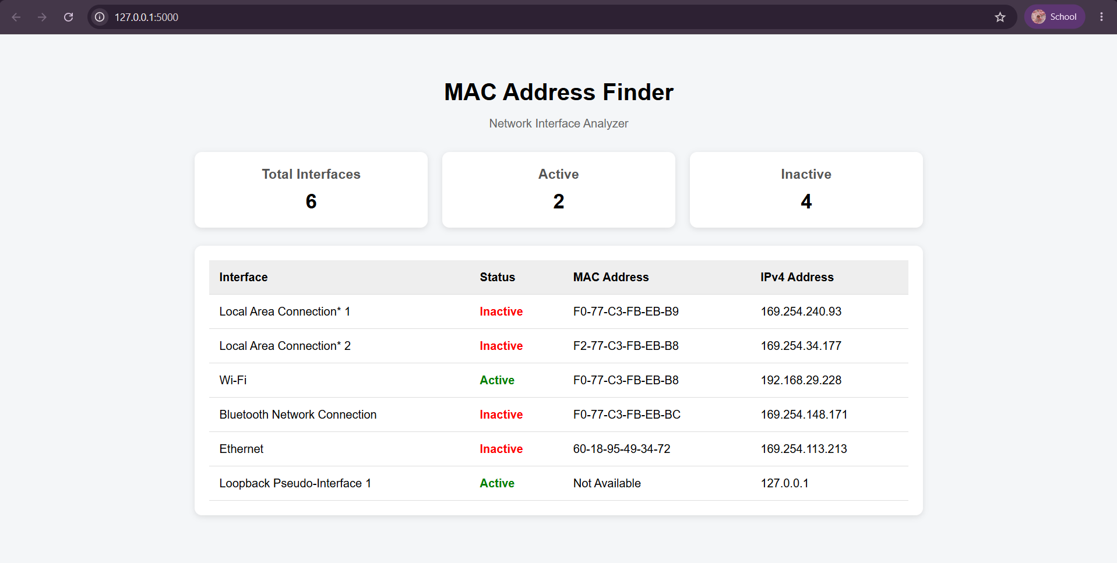
- IPv4 Address: IPv4 address associated with the interface

Discussion:
The system achieved its objective of transforming static academic marks into actionable insights. The prediction logic allows early intervention. The centralized analytics function improved maintainability and reduced redundancy. The subject-detail page provides deeper academic insights per subject, enhancing coordinator-level oversight.

CHAPTER 4
FUTURE SCOPE
The project can be extended in the future with additional networking features such as:
- Detecting devices connected to the local network.
- MAC address vendor identification.
- Network connectivity checking.
- Detailed IPv4 and IPv6 information.
- Network speed and interface statistics.
- Network traffic monitoring.
- Exporting the detected information to a file.
- Developing the application as a desktop or mobile-compatible utility.
These features are outside the current scope but can be added if the application is developed into a more complete network-management tool.

CHAPTER 5
CONCLUSION
The MAC Address Finder project successfully provides a simple way to identify and display the MAC addresses of network interfaces available on a computer. Using Python, psutil, and Flask, the application retrieves actual network-interface information and presents it through a user-friendly web interface.
The project demonstrates practical Computer Networks concepts such as MAC addressing, IPv4 addressing, network interfaces, and Data Link Layer communication, while also showing how networking concepts can be implemented in a practical software application.

